E HealthCare Management System

A PROJECT REPORT
Submitted by
BARSHARANI BEHERA
(230301120537)
in partial fulfilment for the award of the degree of

BACHELOR OF TECHNOLOGY
In
COMPUTER SCIENCE AND ENGINEERING



SCHOOL OF ENGINEERING AND TECHNOLOGY
BHUBANESWAR CAMPUS
CENTURION UNIVERSITY OF TECHNOLOGY AND MANAGEMENT
ODISHA

MAY 2024

CERTIFICATE

DEPARTMENT OF COMPUTER SCIENCE AND ENGINEERING
SCHOOL OF ENGINEERING AND TECHNOLOGY
BHUBANESWAR CAMPUS

BONAFIDE CERTIFICATE

Certified that this project report E HealthCare Management System is the bonafide work of Barsharani Behera who carried out the project work under my supervision. This is to further certify to the best of my knowledge, that this project has not been carried out earlier in this institute and the university.

SIGNATURE

(Prof. Sabyasachi Mohanty)
Professor of Computer Science and Engineering

Certified that the above-mentioned project has been duly carried out as per the norms of the college and statutes of the university.

SIGNATURE
(Prof. Rajkumar Mohanto)
HEAD OF THE DEPARTMENT / DEAN OF THE SCHOOL
Professor of Computer Science and Engineering

DEPARTMENT SEAL

DECLARATION

I hereby declare that the project entitled “E HealthCare Management System” submitted in 3rd semester B. Tech in Computer Science and Engineering is my original work and the project has not formed the basis for the award of any Degree / Diploma or any other similar titles in any other University / Institute.

Name of the Student: Barsharani Behera
Signature of the Student:
Registration No: 230301120537
Place: Bhubaneswar
Date:

ACKNOWLEDGEMENTS

I wish to express my profound and sincere gratitude to Prof. Sabyasachi Mohanty, Professor of Computer Science and Engineering, SoET, Bhubaneswar Campus, who guided me into the intricacies of this project nonchalantly with matchless magnanimity.
I thank Prof. Rajkumar Mohanto, Head of the Dept. of Department of Computer Science and Engineering, SoET, Bhubaneswar Campus and Prof. Sujata Chakrabarti, Dean, School of Engineering and Technology, Bhubaneswar Campus for extending their support during Course of this investigation.
I would be failing in my duty if I don’t acknowledge the cooperation rendered during various stages of image interpretation by Prof. Sabyasachi Mohanty
I am highly grateful to Prof. Sabyasachi Mohanty who evinced keen interest and invaluable support in the progress and successful completion of my project work.
I am indebted to my parents for their constant encouragement, co-operation and help. Words of gratitude are not enough to describe the accommodation and fortitude which they have shown throughout my endeavor.

Name of the Student: Barsharani Behera
Signature of the Student:
Registration No: 230301120537
Place: Bhubaneswar
Date:

TABLE OF CONTENTS
CHAPTER NO. TITLE PAGE NO.
CERTIFICATE 4
DECLARATION 5
ACKNOWLEDGEMENT 6
ABSTRACT 7
- CHAPTER - 1 INTRODUCTION 8
- CHAPTER - 2 SYSTEM CONFIGURATION 9
- CHAPTER – 3 SYNTAX AND METHEDOLOGY 10
- CHAPTER – 4 CODE IMPLEMENTATION 20
CONCLUSION
FUTURE SCOPE
REFERENCES

Abstract:
The E-Healthcare Management System (EHMS) is a software solution designed to improve the management of healthcare services. Developed using Java and MySQL, it helps in managing patient information, scheduling appointments, maintaining medical records, handling billing, and inventory control efficiently. The system aims to enhance data accuracy and streamline hospital operations, making it easier for healthcare providers to deliver quality care. Future improvements could include features like telemedicine and mobile app integration to further enhance its capabilities.

CHAPTER – 1: INTRODUCTION
The E-Healthcare Management System (EHMS) is an innovative project designed to enhance the efficiency of healthcare services by utilizing modern technology. Developed using Java for its robust and platform-independent capabilities, and MySQL for reliable data management, this system aims to streamline various aspects of hospital operations. EHMS automates tasks such as patient registration, appointment scheduling, medical records maintenance, and billing, making the entire process more efficient and reducing the administrative burden on healthcare professionals.
By integrating these functions into a single, user-friendly platform, EHMS ensures accurate and secure management of patient data. The use of Java provides a flexible and scalable solution, while MySQL ensures efficient handling of extensive and sensitive data. This project not only addresses the current challenges in healthcare management but also lays the foundation for future advancements, such as telemedicine integration and mobile applications, ultimately improving the quality of patient care and operational efficiency in healthcare facilities.

CHAPTER – 2: SYSTEM CONFIGURATION
In this project we have used:
- Hardware:
  - Monitor
  - CPU
  - Keyboard
  - Mouse
- Software:
  - IntelliJ IDEA
  - FernFlower decompiler
  - My Sql
  - Jdbc driver
  - jar

CHAPTER – 3: SYNTAX AND METHEDOLOGY

Login page:
package healthcare.management.System;
import javax.swing.* ;
import java.awt.*;
import java.awt.event.ActionEvent;
import java.awt.event.ActionListener;
import java.sql.ResultSet;

public class Login extends JFrame implements ActionListener {
JTextField textField;
JPasswordField jPasswordField;
JButton b1,b2;

Login(){
JLabel namelable = new JLabel("Username");
namelable.setBounds(40,20,100,30);
namelable.setFont(new Font("Tahoma",Font.BOLD,16));
namelable.setForeground(Color.BLACK);
add(namelable);

JLabel password= new JLabel("password");
password.setBounds(40,70,100,30);
password.setFont(new Font("Tahoma",Font.BOLD,16));
password.setForeground(Color.BLACK);
add(password);

textField = new JTextField();
textField.setBounds(150,20,150,30);
textField.setFont(new Font("Tahoma",Font.PLAIN,15));
textField.setBackground(new Color(255,179,0));
add(textField);

jPasswordField = new JPasswordField();
jPasswordField.setBounds(150,70,150,30);
jPasswordField.setFont(new Font("Tahoma",Font.PLAIN,15));
jPasswordField.setBackground(new Color(255,179,0));
add(jPasswordField);

ImageIcon imageIcon = new ImageIcon(ClassLoader.getSystemResource("icon/Green and White Modern Medical Logo (1).png"));
Image i1 = imageIcon.getImage().getScaledInstance(300,300,Image.SCALE_DEFAULT);
ImageIcon imageIcon1 = new ImageIcon(i1);
JLabel label = new JLabel(imageIcon1);
label.setBounds(320,0,300,300);
add(label);

b1 = new JButton("Login");
b1.setBounds(40,140,120,30);
b1.setFont(new Font("serif",Font.BOLD,15));
b1.setBackground(Color.BLACK);
b1.setForeground(Color.WHITE);
b1.addActionListener(this);
add(b1);

b2 = new JButton("Cancle");
b2.setBounds(180,140,120,30);
b2.setFont(new Font("serif",Font.BOLD,15));
b2.setBackground(Color.BLACK);
b2.setForeground(Color.WHITE);
b2.addActionListener(this);
add(b2);
setUndecorated(true);
getContentPane().setBackground(new Color(14, 136, 140));
setSize(750,300);
setLocation(400,270);
setLayout(null);
setVisible(true);

}
public static void main(String [] args){
new Login();
}
@Override
public void actionPerformed(ActionEvent e) {
if (e.getSource()==b1){
try{
conn c = new conn();
String user = textField.getText();
String pass = jPasswordField.getText();
String q = "select * from login where ID = '"+user+"' and Pw ='"+pass+"'";
ResultSet resultSet = c.statement.executeQuery(q);
if(resultSet.next()){
new Reception();
setVisible(false);
}else{
JOptionPane.showMessageDialog(null,"Invalid");
}
}catch(Exception E){
E.printStackTrace();
}
}else {
System.exit(10);
}
}
}
Reception page:
(package healthcare.management.System;
import javax.swing.*;
import java.awt.*;
import java.awt.event.ActionEvent;
import java.awt.event.ActionListener;
public class Reception extends JFrame {
Reception(){
JPanel panel = new JPanel();
panel.setLayout(null);
panel.setBounds(5,160,1525,670);
panel.setBackground(new Color(0,125,130));
add(panel);
JPanel panel1 = new JPanel();
panel1.setLayout(null);
panel1.setBounds(5,5,1525,150);
panel1.setBackground(new Color(0,125,130));
add(panel1);
ImageIcon i11 = new ImageIcon(ClassLoader.getSystemResource("icon/WhatsApp Image 2024-10-28 at 12.37.45_39cb79b1.jpg"));
Image image1 = i11.getImage().getScaledInstance(250,250,Image.SCALE_DEFAULT);
ImageIcon i22 = new ImageIcon(image1);
JLabel label1 = new JLabel(i22);
label1.setBounds(1300,0,250,250);
panel1.add(label1);
ImageIcon i1 = new ImageIcon(ClassLoader.getSystemResource("icon/WhatsApp Image 2024-10-28 at 12.37.46_047a2a0e.jpg"));
Image image = i1.getImage().getScaledInstance(300,100,Image.SCALE_DEFAULT);
ImageIcon i2 = new ImageIcon(image);
JLabel label = new JLabel(i2);
label.setBounds(1000,50,300,100);
panel1.add(label);
JButton btn1 = new JButton("Add New Patient");
btn1.setBounds(30,15,200,30);
btn1.setBackground(new Color(246,215,118));
panel1.add(btn1);
btn1.addActionListener(new ActionListener() {
@Override
public void actionPerformed(ActionEvent e) {
new NEW_PATIENT();
}
});

JButton btn2 = new JButton("Room");
btn2.setBounds(30,58,200,30);
btn2.setBackground(new Color(246,215,118));
panel1.add(btn2);
btn2.addActionListener(new ActionListener() {
@Override
public void actionPerformed(ActionEvent e) {
new Room();
}
});
JButton btn3 = new JButton("Department");
btn3.setBounds(30,100,200,30);
btn3.setBackground(new Color(246,215,118));
panel1.add(btn3);
btn3.addActionListener(new ActionListener() {
@Override
public void actionPerformed(ActionEvent e) {
new Department();
}
});
JButton btn4 = new JButton("All Employee Info");
btn4.setBounds(270,15,200,30);
btn4.setBackground(new Color(246,215,118));
panel1.add(btn4);
btn4.addActionListener(new ActionListener() {
@Override
public void actionPerformed(ActionEvent e) {
new Employee_Info();
}
});
JButton btn5 = new JButton("Patient Info");
btn5.setBounds(270,58,200,30);
btn5.setBackground(new Color(246,215,118));
panel1.add(btn5);
btn5.addActionListener(new ActionListener() {
@Override
public void actionPerformed(ActionEvent e) {
new All_Patient_Info();
}
});

JButton btn6 = new JButton("Patient Discharge");

btn6.setBounds(270,100,200,30);

btn6.setBackground(new Color(246,215,118));

panel1.add(btn6);

btn6.addActionListener(new ActionListener() {
@Override
public void actionPerformed(ActionEvent e) {
new Patient_Discharge();
}
});
JButton btn7 = new JButton("Update Patient Details");
btn7.setBounds(510,15,200,30);
btn7.setBackground(new Color(246,215,118));
panel1.add(btn7);
btn7.addActionListener(new ActionListener() {
@Override
public void actionPerformed(ActionEvent e) {
new update_patient_details();
}
});
JButton btn8 = new JButton("Hospital Ambulance");
btn8.setBounds(510,58,200,30);
btn8.setBackground(new Color(246,215,118));
panel1.add(btn8);
btn8.addActionListener(new ActionListener() {
@Override
public void actionPerformed(ActionEvent e) {
new Ambulance();
}
});
JButton btn9 = new JButton("Search Room");
btn9.setBounds(510,100,200,30);
btn9.setBackground(new Color(246,215,118));
panel1.add(btn9);
btn9.addActionListener(new ActionListener() {
@Override
public void actionPerformed(ActionEvent e) {
new Search_Room();
}
});
JButton btn10 = new JButton("Logout");
btn10.setBounds(790,100,200,30);
btn10.setBackground(new Color(246,215,118));
panel1.add(btn10);
btn10.addActionListener(new ActionListener() {
@Override
public void actionPerformed(ActionEvent e) {
setVisible(false);
new Login();
}
});
setSize(1950,1090);
setLayout(null);
getContentPane().setBackground(Color.white);
setVisible(true);
}
public static void main (String [] args){
new Reception);
}
}

Connection Class:

package healthcare.management.System;

import java.sql.DriverManager;

import java.sql.Statement;

import java.sql.Connection;

public class conn {

Connection connection;

Statement statement;

public conn(){

try{

connection = DriverManager.getConnection("jdbc:mysql://localhost:3306/healthcare", "root","1305");

statement = connection.createStatement();

}catch (Exception e){

e.printStackTrace();

}

}

}

New patient class:

package healthcare.management.System;

import javax.swing.*;

import javax.xml.transform.Result;

import java.awt.*;

import java.awt.event.ActionEvent;

import java.awt.event.ActionListener;

import java.sql.ResultSet;

import java.util.Date;

public class NEW_PATIENT extends JFrame implements ActionListener {

JComboBox comboBox;

JTextField textFieldNumber, textName, textFieldDisease , textFieldDeposite ;

JRadioButton r1,r2;

Choice c1;

JLabel date;

JButton b1,b2;

NEW_PATIENT(){

JPanel panel = new JPanel();

panel.setBounds(5,5,850,540);

panel.setBackground(new Color(90,156,163));

panel.setLayout(null);

add(panel);

ImageIcon imageIcon = new ImageIcon(ClassLoader.getSystemResource("icon/WhatsApp Image 2024-10-28 at 12.37.45_8eb8e7e0.jpg"));

Image image = imageIcon.getImage().getScaledInstance(200,200,Image.SCALE_DEFAULT);

ImageIcon imageIcon1 = new ImageIcon(image);

JLabel label = new JLabel(imageIcon1);

label.setBounds(600,150,200,200);

panel.add(label);

JLabel labelName = new JLabel("NEW PATIENT FORM");

labelName.setBounds(118,11,260,53);

labelName.setFont(new Font("Tahoma",Font.BOLD,20));

panel.add(labelName);

JLabel labelID = new JLabel("ID");

labelID.setBounds(35,76,200,14);

labelID.setFont(new Font("Tahoma",Font.BOLD,14));

labelID.setForeground(Color.WHITE);

panel.add(labelID);

comboBox = new JComboBox(new String[] {"Aadhar Card","Voter Id","Driving License","Pan"});

comboBox.setBounds(271,73,150,20);

comboBox.setBackground(new Color(3,45,48));

comboBox.setFont(new Font("Tahoma",Font.BOLD,14));

panel.add(comboBox);

JLabel labelNumber = new JLabel("Number ");

labelNumber.setBounds(35,111,200,14);

labelNumber.setFont(new Font("Tahoma",Font.BOLD,14));

labelNumber.setForeground(Color.WHITE);

panel.add(labelNumber);

textFieldNumber = new JTextField();

textFieldNumber.setBounds(271,111,150,20);

panel.add(textFieldNumber);

JLabel labelName1 = new JLabel("Name :");

labelName1.setBounds(35,151,200,14);

labelName1.setFont(new Font("Tahoma",Font.BOLD,14));

labelName1.setForeground(Color.WHITE);

panel.add(labelName1);

textName = new JTextField();

textName.setBounds(271,151,150,20);

panel.add(textName);

JLabel labelGender = new JLabel("Gender :");

labelGender.setBounds(35,191,200,14);

labelGender.setFont(new Font("Tahoma",Font.BOLD,14));

labelGender.setForeground(Color.WHITE);

panel.add(labelGender);

r1 = new JRadioButton("Male");

r1.setFont(new Font("Tahoma",Font.BOLD,14));

r1.setForeground(Color.WHITE);

r1.setBackground(new Color(109,164,170));

r1.setBounds(271,191,80,12);

panel.add(r1);

r2 = new JRadioButton("Female");

r2.setFont(new Font("Tahoma",Font.BOLD,14));

r2.setForeground(Color.WHITE);

r2.setBackground(new Color(109,164,170));

r2.setBounds(350,191,80,12);

panel.add(r2);

JLabel labelDisease = new JLabel("Disease :");

labelDisease.setBounds(35,231,200,14);

labelDisease.setFont(new Font("Tahoma",Font.BOLD,14));

labelDisease.setForeground(Color.WHITE);

panel.add(labelDisease);

textFieldDisease = new JTextField();

textFieldDisease.setBounds(271,231,150,20);

panel.add(textFieldDisease);

JLabel labelRoom = new JLabel("Room :");

labelRoom.setBounds(35,274,200,14);

labelRoom.setFont(new Font("Tahoma",Font.BOLD,14));

labelRoom.setForeground(Color.WHITE);

panel.add(labelRoom);

c1 = new Choice();

try{

conn c = new conn();

ResultSet resultSet = c.statement.executeQuery("select * from Room");

while(resultSet.next()){

c1.add(resultSet.getNString("Room_no"));

}

}catch (Exception e){

e.printStackTrace();

}

c1.setBounds(271,274,150,20);

c1.setFont(new Font("Tahoma",Font.BOLD,14));

c1.setForeground(Color.WHITE);

c1.setBackground(new Color(3,45,48));

panel.add(c1);

JLabel labelDate = new JLabel("Time :");

labelDate.setBounds(35,316,200,14);

labelDate.setFont(new Font("Tahoma",Font.BOLD,14));

labelDate.setForeground(Color.WHITE);

panel.add(labelDate);

Date date1 = new Date();

date = new JLabel(""+date1);

date.setBounds(271,316,250,14);

date.setForeground(Color.WHITE);

date.setFont(new Font("Tahoma",Font.BOLD,14));

panel.add(date);

JLabel labelDeposite = new JLabel("Deposite :");

labelDeposite.setBounds(35,359,200,17);

labelDeposite.setFont(new Font("Tahoma",Font.BOLD,14));

labelDeposite.setForeground(Color.WHITE);

panel.add(labelDeposite);

textFieldDeposite = new JTextField();

textFieldDeposite.setBounds(271,359,150,20);

panel.add(textFieldDeposite);

b1 = new JButton("ADD");

b1.setBounds(90,430,120,30);

b1.setForeground(Color.WHITE);

b1.setBackground(Color.BLACK);

b1.addActionListener(this);

panel.add(b1);

b2 = new JButton("BACK");

b2.setBounds(260,430,120,30);

b2.setForeground(Color.WHITE);

b2.setBackground(Color.BLACK);

b2.addActionListener(this);

panel.add(b2);

setUndecorated(true);

setSize(850,550);

setLayout(null);

setLocation(300,250);

setVisible(true);

}

public static void main(String [] args){

new NEW_PATIENT();

}

@Override

public void actionPerformed(ActionEvent e) {

if(e.getSource()==b1){

conn c= new conn();

String radioBTN = null;

if(r1.isSelected()){

radioBTN = "Male";

}else if(r2.isSelected()){

radioBTN = "Female";

}

String s1= (String) comboBox.getSelectedItem();

String s2= textFieldNumber.getText();

String s3= textName.getText();

String s4= radioBTN;

String s5 = textFieldDisease.getText();

String s6 = c1.getSelectedItem();

String s7 = date.getText();

String s8 = textFieldDeposite.getText();

try{

String q = "insert into Patient_info values('"+s1+"','"+s2+"','"+s3+"','"+s4+"','"+s5+"','"+s6+"','"+s7+"','"+s8+"')";

String q1 ="update room set Avalability = 'Occupied' where room_no ="+s6;

c.statement.executeUpdate(q);

c.statement.executeUpdate(q1);

JOptionPane.showMessageDialog(null,"Added Successfully");

setVisible(false);

}catch (Exception E){

E.printStackTrace();

}

}else{

setVisible(false);

}

}

}

All patient info:

package healthcare.management.System;

import net.proteanit.sql.DbUtils;

import javax.swing.*;

import java.awt.*;

import java.awt.event.ActionEvent;

import java.awt.event.ActionListener;

import java.sql.ResultSet;

public class All_Patient_Info extends JFrame {

All_Patient_Info(){

JPanel panel= new JPanel();

panel.setBounds(5,5,900,550);

panel.setBackground(new Color(109,164,170));

panel.setLayout(null);

add(panel);

JTable table = new JTable();

table.setBounds(10,40,900,450);

table.setBackground(new Color(109,164,170));

table.setFont(new Font("Tahoma",Font.PLAIN,12));

panel.add(table);

JLabel label1=new JLabel("ID");

label1.setBounds(10,8,105,20);

label1.setFont(new Font("Tahoma",Font.BOLD,14));

panel.add(label1);

JLabel label2=new JLabel("Number");

label2.setBounds(130,8,150,20);

label2.setFont(new Font("Tahoma",Font.BOLD,14));

panel.add(label2);

JLabel label3=new JLabel("Name");

label3.setBounds(240,8,105,20);

label3.setFont(new Font("Tahoma",Font.BOLD,14));

panel.add(label3);

JLabel label4=new JLabel("Gender");

label4.setBounds(350,8,150,20);

label4.setFont(new Font("Tahoma",Font.BOLD,14));

panel.add(label4);

JLabel label5=new JLabel("Disease");

label5.setBounds(470,8,105,20);

label5.setFont(new Font("Tahoma",Font.BOLD,14));

panel.add(label5);

JLabel label6=new JLabel("Room no");

label6.setBounds(580,8,150,20);

label6.setFont(new Font("Tahoma",Font.BOLD,14));

panel.add(label6);

JLabel label7=new JLabel("Time");

label7.setBounds(690,8,105,20);

label7.setFont(new Font("Tahoma",Font.BOLD,14));

panel.add(label7);

JLabel label8=new JLabel("Deposite");

label8.setBounds(800,8,150,20);

label8.setFont(new Font("Tahoma",Font.BOLD,14));

panel.add(label8);

JButton button = new JButton("BACK");

button.setBounds(380,500,120,20);

button.setBackground(Color.BLACK);

button.setForeground(Color.white);

panel.add(button);

button.addActionListener(new ActionListener() {

@Override

public void actionPerformed(ActionEvent e) {

setVisible(false);

}

});

try{

conn c = new conn();

String q = "select * from Patient_Info";

ResultSet resultSet = c.statement.executeQuery(q);

table.setModel(DbUtils.resultSetToTableModel(resultSet));

}catch(Exception e){

e.printStackTrace();

}

setUndecorated(true);

setSize(900,600);

setLayout(null);

setLocation(430,200);

setVisible(true);

}

public static void main(String [] args){

new All_Patient_Info();

}

}

Department class:

package healthcare.management.System;

import net.proteanit.sql.DbUtils;

import javax.swing.*;

import java.awt.*;

import java.awt.event.ActionEvent;

import java.awt.event.ActionListener;

import java.sql.ResultSet;

public class Department extends JFrame {

Department(){

JPanel panel = new JPanel();

panel.setBounds(5,5,690,690);

panel.setLayout(null);

panel.setBackground(new Color(90,156,163));

add(panel);

JTable table = new JTable();

table.setBounds(0,40,700,350);

table.setBackground(new Color(90,156,163));

table.setFont(new Font("Tahoma", Font.BOLD,14));

panel.add(table);

try{

conn c = new conn();

String q = "select * from department";

ResultSet resultSet= c.statement.executeQuery(q);

table.setModel(DbUtils.resultSetToTableModel(resultSet));

}catch (Exception e){

e.printStackTrace();

}

JLabel label1=new JLabel("Department");

label1.setBounds(145,11,105,20);

label1.setFont(new Font("Tahoma",Font.BOLD,14));

panel.add(label1);

JLabel label2=new JLabel("Phone Number");

label2.setBounds(431,11,150,20);

label2.setFont(new Font("Tahoma",Font.BOLD,14));

panel.add(label2);

JButton b1 = new JButton("BACK");

b1.setBounds(300,410,130,20);

b1.setBackground(Color.BLACK);

b1.setForeground(Color.white);

panel.add(b1);

b1.addActionListener(new ActionListener() {

@Override

public void actionPerformed(ActionEvent e) {

setVisible(false);

}

});

setUndecorated(true);

setSize(700,500);

setLayout(null);

setLocation(350,250);

setVisible(true);

}

public static void main (String [] args){

new Department();

}

}

Employee Info Class:

package healthcare.management.System;

import net.proteanit.sql.DbUtils;

import javax.swing.*;

import java.awt.*;

import java.awt.event.ActionEvent;

import java.awt.event.ActionListener;

import java.sql.ResultSet;

public class Employee_Info extends JFrame {

Employee_Info(){

JPanel panel= new JPanel();

panel.setBounds(5,5,990,590);

panel.setBackground(new Color(109,164,170));

panel.setLayout(null);

add(panel);

JTable table = new JTable();

table.setBounds(10,34,980,450);

table.setBackground(new Color(109,164,170));

panel.add(table);

try{

conn c = new conn();

String q = "select * from EMP_INFO";

ResultSet resultSet = c.statement.executeQuery(q);

table.setModel(DbUtils.resultSetToTableModel(resultSet));

}catch(Exception e){

e.printStackTrace();

}

JLabel label1=new JLabel("Name");

label1.setBounds(10,8,105,20);

label1.setFont(new Font("Tahoma",Font.BOLD,14));

panel.add(label1);

JLabel label2=new JLabel("Age");

label2.setBounds(180,8,150,20);

label2.setFont(new Font("Tahoma",Font.BOLD,14));

panel.add(label2);

JLabel label3=new JLabel("Phone Number");

label3.setBounds(337,8,105,20);

label3.setFont(new Font("Tahoma",Font.BOLD,14));

panel.add(label3);

JLabel label4=new JLabel("Salary");

label4.setBounds(500,8,150,20);

label4.setFont(new Font("Tahoma",Font.BOLD,14));

panel.add(label4);

JLabel label5=new JLabel("Gmail");

label5.setBounds(670,8,105,20);

label5.setFont(new Font("Tahoma",Font.BOLD,14));

panel.add(label5);

JLabel label6=new JLabel("Aadhar Number");

label6.setBounds(828,8,150,20);

label6.setFont(new Font("Tahoma",Font.BOLD,14));

panel.add(label6);

JButton button = new JButton("BACK");

button.setBounds(400,500,120,20);

button.setBackground(Color.BLACK);

button.setForeground(Color.white);

panel.add(button);

button.addActionListener(new ActionListener() {

@Override

public void actionPerformed(ActionEvent e) {

setVisible(false);

}

});

setUndecorated(true);

setSize(1000,600);

setLayout(null);

setLocation(350,230);

setVisible(true);

}

public static void main(String[] args){

new Employee_Info();

}

}

Room Class:

package healthcare.management.System;

import net.proteanit.sql.DbUtils;

import javax.swing.*;

import java.awt.*;

import java.awt.event.ActionEvent;

import java.awt.event.ActionListener;

import java.sql.ResultSet;

public class Room extends JFrame {

JTable table;

Room(){

JPanel panel = new JPanel();

panel.setBounds(5,5,890,590);

panel.setBackground(new Color(90,156,163));

panel.setLayout(null);

add(panel);

ImageIcon imageIcon = new ImageIcon(ClassLoader.getSystemResource("icon/WhatsApp Image 2024-10-28 at 12.37.44_56b6c66b.jpg"));

Image image = imageIcon.getImage().getScaledInstance(200,200,Image.SCALE_DEFAULT);

ImageIcon imageIcon1 = new ImageIcon(image);

JLabel label = new JLabel(imageIcon1);

label.setBounds(600,200,200,200);

panel.add(label);

table = new JTable();

table.setBounds(10,40,500,400);

table.setBackground(new Color(90,156,163));

panel.add(table);

try{

conn c = new conn();

String q = "select * from Room";

ResultSet resultSet = c.statement.executeQuery(q);

table.setModel(DbUtils.resultSetToTableModel(resultSet));

}catch(Exception e){

e.printStackTrace();

}

JLabel label1 = new JLabel("Room no");

label1.setBounds(12,15,80,15);

label1.setFont(new Font("Tahoma",Font.BOLD,14));

panel.add(label1);

JLabel label2 = new JLabel("Availability");

label2.setBounds(140,15,80,15);

label2.setFont(new Font("Tahoma",Font.BOLD,14));

panel.add(label2);

JLabel label3 = new JLabel("Price");

label3.setBounds(250,15,80,15);

label3.setFont(new Font("Tahoma",Font.BOLD,14));

panel.add(label3);

JLabel label4 = new JLabel("Room Type");

label4.setBounds(390,15,80,15);

label4.setFont(new Font("Tahoma",Font.BOLD,14));

panel.add(label4);

JButton back = new JButton("Back");

back.setBounds(200,500,120,30);

back.setBackground(Color.BLACK);

back.setForeground(Color.white);

panel.add(back);

back.addActionListener(new ActionListener() {

@Override

public void actionPerformed(ActionEvent e) {

setVisible(false);

}

});

setUndecorated(true);

setSize(900,600);

setLayout(null);

setLocation(300,230);

setVisible(true);

}

public static void main(String[] args){

new Room();

}

}

Search Room Class:

package healthcare.management.System;

import net.proteanit.sql.DbUtils;

import javax.swing.*;

import java.awt.*;

import java.awt.event.ActionEvent;

import java.awt.event.ActionListener;

import java.sql.ResultSet;

public class Search_Room extends JFrame {

Choice choice;

JTable table;

Search_Room(){

JPanel panel = new JPanel();

panel.setBounds(5,5,690,490);

panel.setBackground(new Color(90, 156, 163));

panel.setLayout(null);

add(panel);

JLabel For = new JLabel("Search For Room");

For.setBounds(250,11,186,31);

For.setForeground(Color.white);

For.setFont(new Font("Tahoma",Font.BOLD,20));

panel.add(For);

JLabel status = new JLabel("Status :");

status.setBounds(70,70,80,20);

status.setForeground(Color.white);

status.setFont(new Font("Tahoma",Font.BOLD,14));

panel.add(status);

choice =new Choice();

choice.setBounds(170,70,120,20);

choice.add("Available");

choice.add("Occupied");

panel.add(choice);

table = new JTable();

table.setBounds(0,187,700,210);

table.setBackground(new Color(90, 156, 163));

table.setForeground(Color.white);

panel.add(table);

try {

conn c = new conn();

String q = "select * from room";

ResultSet resultSet = c.statement.executeQuery(q);

table.setModel(DbUtils.resultSetToTableModel(resultSet));

}catch (Exception e){

e.printStackTrace();

}

JLabel Roomno = new JLabel("Room Number");

Roomno.setBounds(23,162,150,20);

Roomno.setForeground(Color.white);

Roomno.setFont(new Font("Tahoma",Font.BOLD,14));

panel.add(Roomno);

JLabel available = new JLabel("Availability");

available.setBounds(175,162,150,20);

available.setForeground(Color.white);

available.setFont(new Font("Tahoma",Font.BOLD,14));

panel.add(available);

JLabel price = new JLabel("Price");

price.setBounds(458,162,150,20);

price.setForeground(Color.white);

price.setFont(new Font("Tahoma",Font.BOLD,14));

panel.add(price);

JLabel Bed = new JLabel("Bed Type");

Bed.setBounds(580,162,150,20);

Bed.setForeground(Color.white);

Bed.setFont(new Font("Tahoma",Font.BOLD,14));

panel.add(Bed);

JButton Search = new JButton("Search");

Search.setBounds(200,420,120,25);

Search.setBackground(Color.black);

Search.setForeground(Color.white);

panel.add(Search);

Search.addActionListener(new ActionListener() {

@Override

public void actionPerformed(ActionEvent e) {

String q = "select * from Room where Avalability = '"+choice.getSelectedItem()+"'";

try {

conn c = new conn();

ResultSet resultSet = c.statement.executeQuery(q);

table.setModel(DbUtils.resultSetToTableModel(resultSet));

}catch (Exception E){

E.printStackTrace();

}

}

});

JButton Back = new JButton("Back");

Back.setBounds(380,420,120,25);

Back.setBackground(Color.black);

Back.setForeground(Color.white);

panel.add(Back);

Back.addActionListener(new ActionListener() {

@Override

public void actionPerformed(ActionEvent e) {

setVisible(false);

}

});

setUndecorated(true);

setSize(700,500);

setLayout(null);

setLocation(450,250);

setVisible(true);

}

public static void main(String[] args){

new Search_Room();

}

}

Update Patient Detail Class:

package healthcare.management.System;

import javax.swing.*;

import java.awt.*;

import java.awt.event.ActionEvent;

import java.awt.event.ActionListener;

import java.sql.ResultSet;

public class update_patient_details extends JFrame {

update_patient_details(){

JPanel panel= new JPanel();

panel.setBounds(5,5,940,490);

panel.setBackground(new Color(90,156,163));

panel.setLayout(null);

add(panel);

ImageIcon imageIcon = new ImageIcon(ClassLoader.getSystemResource("icon/WhatsApp Image 2024-10-28 at 12.37.45_02a32cb6.jpg"));

Image image = imageIcon.getImage().getScaledInstance(300,300,Image.SCALE_DEFAULT);

ImageIcon imageIcon1 = new ImageIcon(image);

JLabel label = new JLabel(imageIcon1);

label.setBounds(500,60,300,300);

panel.add(label);

JLabel label1 = new JLabel("Update Patient Details");

label1.setBounds(124,11,260,25);

label1.setFont(new Font("tahoma",Font.BOLD,20));

label1.setForeground(Color.white);

panel.add(label1);

JLabel label2 = new JLabel("Name :");

label2.setBounds(25,88,100,14);

label2.setFont(new Font("tahoma",Font.PLAIN,14));

label2.setForeground(Color.white);

panel.add(label2);

Choice choice = new Choice();

choice.setBounds(248,85,100,25);

panel.add(choice);

try{

conn c = new conn();

ResultSet resultSet = c.statement.executeQuery("select * from Patient_Info");

while (resultSet.next()){

choice.add(resultSet.getNString("Name"));

}

}catch(Exception e){

e.printStackTrace();

}

JLabel label3 = new JLabel("Room Number :");

label3.setBounds(25,129,100,14);

label3.setFont(new Font("tahoma",Font.PLAIN,12));

label3.setForeground(Color.white);

panel.add(label3);

JTextField textFieldR = new JTextField();

textFieldR.setBounds(248,129,140,20);

panel.add(textFieldR);

JLabel label4 = new JLabel("In-time :");

label4.setBounds(25,174,100,14);

label4.setFont(new Font("tahoma",Font.PLAIN,14));

label4.setForeground(Color.white);

panel.add(label4);

JTextField textFieldINTTime = new JTextField();

textFieldINTTime.setBounds(248,174,140,20);

panel.add(textFieldINTTime);

JLabel label5 = new JLabel("Amount paid(Rs) :");

label5.setBounds(25,216,120,14);

label5.setFont(new Font("tahoma",Font.PLAIN,14));

label5.setForeground(Color.white);

panel.add(label5);

JTextField textFieldAmount = new JTextField();

textFieldAmount.setBounds(248,216,140,20);

panel.add(textFieldAmount);

JLabel label6 = new JLabel("Pending Amount(Rs) :");

label6.setBounds(25,261,150,14);

label6.setFont(new Font("tahoma",Font.PLAIN,14));

label6.setForeground(Color.white);

panel.add(label6);

JTextField textFieldPending = new JTextField();

textFieldPending.setBounds(248,261,140,20);

panel.add(textFieldPending);

JButton check = new JButton("CHECK");

check.setBounds(281,378,89,23);

check.setBackground(Color.BLACK);

check.setForeground(Color.white);

panel.add(check);

check.addActionListener(new ActionListener() {

@Override

public void actionPerformed(ActionEvent e) {

String id = choice.getSelectedItem();

String q = "select * from Patient_Info where Name = '"+id+"'" ;

try{

conn c = new conn();

ResultSet resultSet = c.statement.executeQuery(q);

while(resultSet.next()){

textFieldR.setText(resultSet.getString("Room_Number"));

textFieldINTTime.setText(resultSet.getString("Time"));

textFieldAmount.setText(resultSet.getString("Deposite"));

}

ResultSet resultSet1 = c.statement.executeQuery("select * from room where Room_no='"+textFieldR.getText()+"'");

while (resultSet1.next()){

String price = resultSet1.getNString("Price");

int amountPaid = Integer.parseInt(price)-Integer.parseInt(textFieldAmount.getText());

textFieldAmount.setText(""+amountPaid);

}

}catch(Exception E){

E.printStackTrace();

}

}

});

JButton update = new JButton("UPDATE");

update.setBounds(56,378,89,23);

update.setBackground(Color.BLACK);

update.setForeground(Color.white);

panel.add(update);

update.addActionListener(new ActionListener() {

@Override

public void actionPerformed(ActionEvent e) {

try{

conn c = new conn();

String q = choice.getSelectedItem();

String room = textFieldR.getText();

String time = textFieldINTTime.getText();

String amount = textFieldAmount.getText();

c.statement.executeUpdate("update Patient_Info set Room_Number = '"+room+"',Time='"+time+"',Deposite = '"+amount+"' where name = '"+q+"' ");

JOptionPane.showMessageDialog(null,"Upadated Successfully");

}catch (Exception E){

E.printStackTrace();

}

}

});

JButton back = new JButton("BACK");

back.setBounds(168,378,89,23);

back.setBackground(Color.BLACK);

back.setForeground(Color.white);

panel.add(back);

back.addActionListener(new ActionListener() {

@Override

public void actionPerformed(ActionEvent e) {

setVisible(false);

}

});

setSize(950,500);

setLayout(null);

setLocation(400,250);

setVisible(true);

}

public static void main(String [] args){

new update_patient_details();

}

}

Patient Discharge Class:

package healthcare.management.System;

import javax.swing.*;

import javax.xml.transform.Result;

import java.awt.*;

import java.awt.event.ActionEvent;

import java.awt.event.ActionListener;

import java.sql.ResultSet;

import java.util.Date;

public class Patient_Discharge extends JFrame {

Patient_Discharge(){

JPanel panel= new JPanel();

panel.setBounds(5,5,790,390);

panel.setBackground(new Color(90,156,163));

panel.setLayout(null);

add(panel);

JLabel label = new JLabel("CHECK-OUT");

label.setBounds(100,20,150,20);

label.setFont(new Font("Tahoma",Font.BOLD,20));

label.setForeground(Color.white);

panel.add(label);

JLabel label1 = new JLabel("Customer ID");

label1.setBounds(30,80,150,20);

label1.setFont(new Font("Tahoma",Font.BOLD,14));

label1.setForeground(Color.white);

panel.add(label1);

Choice choice = new Choice();

choice.setBounds(200,80,150,25);

panel.add(choice);

try{

conn c = new conn();

ResultSet resultSet = c.statement.executeQuery("select * from Patient_Info");

while(resultSet.next()){

choice.add(resultSet.getString("number"));

}

}catch (Exception e){

e.printStackTrace();

}

JLabel label2 = new JLabel("Room Number");

label2.setBounds(30,130,150,20);

label2.setFont(new Font("Tahoma",Font.BOLD,14));

label2.setForeground(Color.white);

panel.add(label2);

JLabel RNo = new JLabel();

RNo.setBounds(200,130,150,20);

RNo.setFont(new Font("Tahoma",Font.BOLD,14));

RNo.setForeground(Color.white);

panel.add(RNo);

JLabel label3 = new JLabel("In Time");

label3.setBounds(30,180,150,20);

label3.setFont(new Font("Tahoma",Font.BOLD,14));

label3.setForeground(Color.white);

panel.add(label3);

JLabel INTime = new JLabel();

INTime.setBounds(200,180,250,20);

INTime.setFont(new Font("Tahoma",Font.BOLD,14));

INTime.setForeground(Color.white);

panel.add(INTime);

JLabel label4 = new JLabel("Out Time");

label4.setBounds(30,230,150,20);

label4.setFont(new Font("Tahoma",Font.BOLD,14));

label4.setForeground(Color.white);

panel.add(label4);

Date date = new Date();

JLabel OUTTime = new JLabel(""+date);

OUTTime.setBounds(200,230,250,20);

OUTTime.setFont(new Font("Tahoma",Font.BOLD,14));

OUTTime.setForeground(Color.white);

panel.add(OUTTime);

JButton discharge = new JButton("Discharge");

discharge.setBounds(30,300,120,30);

discharge.setBackground(Color.BLACK);

discharge.setForeground(Color.white);

panel.add(discharge);

discharge.addActionListener(new ActionListener() {

@Override

public void actionPerformed(ActionEvent e) {

conn c = new conn();

try{

c.statement.executeUpdate("delete from Patient_Info where number = '" + choice.getSelectedItem() + "'");

c.statement.executeUpdate("update room set Avalability = 'Available' where Room_no='" + RNo.getText() + "'");

JOptionPane.showMessageDialog(null, "Done");

setVisible(false);

}catch (Exception E){

E.printStackTrace();

}

}

});

JButton Check = new JButton("Check");

Check.setBounds(170,300,120,30);

Check.setBackground(Color.BLACK);

Check.setForeground(Color.white);

panel.add(Check);

Check.addActionListener(new ActionListener() {

@Override

public void actionPerformed(ActionEvent e) {

conn c = new conn();

try{

ResultSet resultSet = c.statement.executeQuery("select * from patient_Info where number = '"+choice.getSelectedItem()+"'");

while(resultSet.next()){

RNo.setText(resultSet.getString("Room_Number"));

INTime.setText(resultSet.getNString("Time"));

}

}catch(Exception E){

E.printStackTrace();

}

}

});

JButton Back = new JButton("Back");

Back.setBounds(300,300,120,30);

Back.setBackground(Color.BLACK);

Back.setForeground(Color.white);

panel.add(Back);

Back.addActionListener(new ActionListener() {

@Override

public void actionPerformed(ActionEvent e) {

setVisible(false);

}

});

setUndecorated(true);

setSize(800,400);

setLayout(null);

setLocation(400,250);

setVisible(true);

}

public static void main(String [] args){

new Patient_Discharge();

}

}

Ambulance Class:

package healthcare.management.System;

import net.proteanit.sql.DbUtils;

import javax.swing.*;

import java.awt.*;

import java.awt.event.ActionEvent;

import java.awt.event.ActionListener;

import java.sql.ResultSet;

public class Ambulance extends JFrame {

Ambulance(){

JPanel panel = new JPanel();

panel.setBounds(5,5,890,590);

panel.setBackground(new Color(90, 156, 163));

panel.setLayout(null);

add(panel);

JTable table = new JTable();

table.setBounds(10,40,900,450);

table.setBackground(new Color(90, 156, 163));

table.setFont(new Font("Tahoma",Font.BOLD,12));

panel.add(table);

try{

conn c = new conn();

String q = "select * from Ambulance";

ResultSet resultSet = c.statement.executeQuery(q);

table.setModel(DbUtils.resultSetToTableModel(resultSet));

}catch (Exception e){

e.printStackTrace();

}

JLabel label1 = new JLabel("Name");

label1.setBounds(31,11,100,14);

label1.setFont(new Font("Tahoma",Font.BOLD,14));

panel.add(label1);

JLabel label2 = new JLabel("Gender");

label2.setBounds(264,11,100,14);

label2.setFont(new Font("Tahoma",Font.BOLD,14));

panel.add(label2);

JLabel label3 = new JLabel("Car name");

label3.setBounds(366,11,100,14);

label3.setFont(new Font("Tahoma",Font.BOLD,14));

panel.add(label3);

JLabel label4 = new JLabel("Available");

label4.setBounds(520,11,100,14);

label4.setFont(new Font("Tahoma",Font.BOLD,14));

panel.add(label4);

JLabel label5 = new JLabel("Location");

label5.setBounds(750,11,100,14);

label5.setFont(new Font("Tahoma",Font.BOLD,14));

panel.add(label5);

JButton button = new JButton("BACK");

button.setBounds(450,510,120,30);

button.setBackground(Color.black);

button.setForeground(Color.white);

panel.add(button);

button.addActionListener(new ActionListener() {

@Override

public void actionPerformed(ActionEvent e) {

setVisible(false);

}

});

setUndecorated(true);

setSize(900,600);

setLayout(null);

setLocation(300,200);

setVisible(true);

}

public static void main(String [] args){

new Ambulance();

}

}

CHAPTER – 4: CODE IMPLEMENTATION
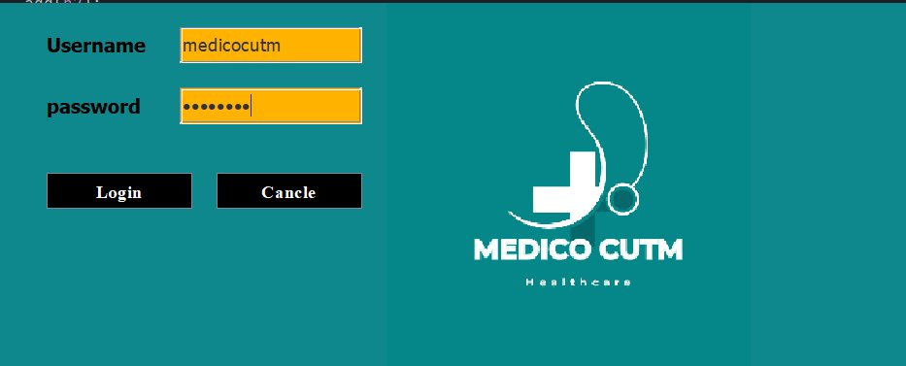
Fig 4.1: Login Page
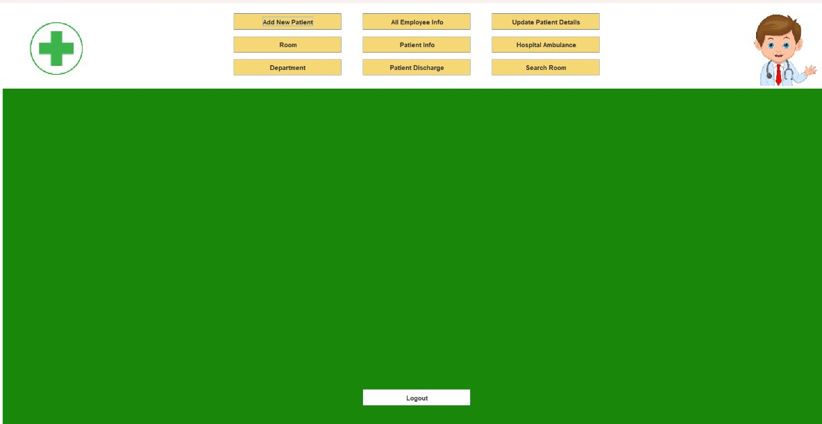
Fig 4.2: Home Page

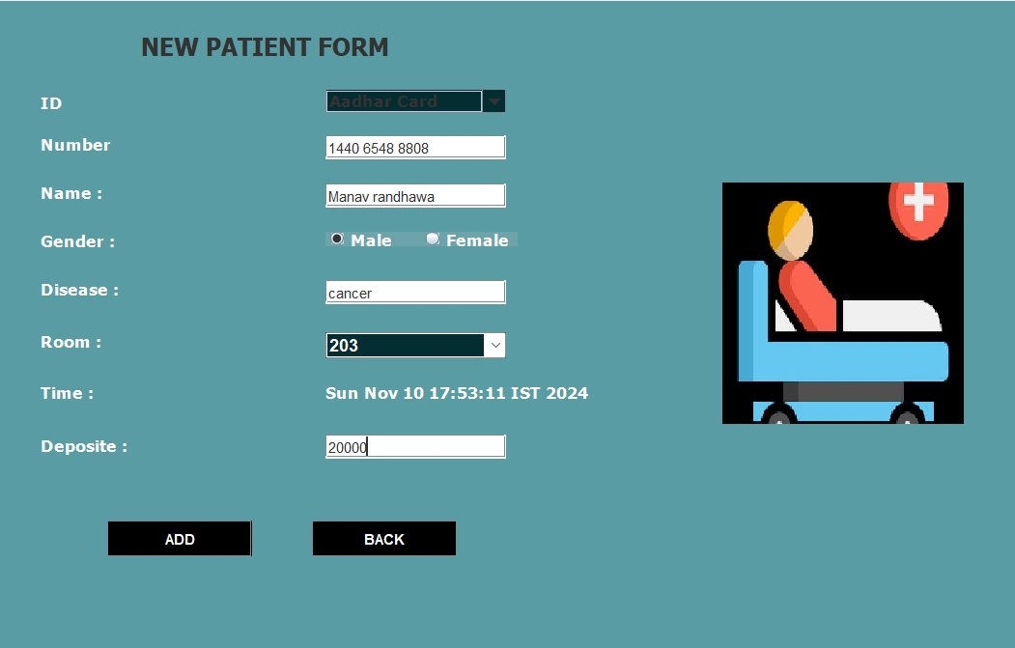
Fig 4.3: New Patient Form
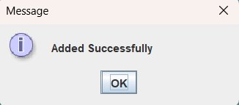
Fig 4.4:
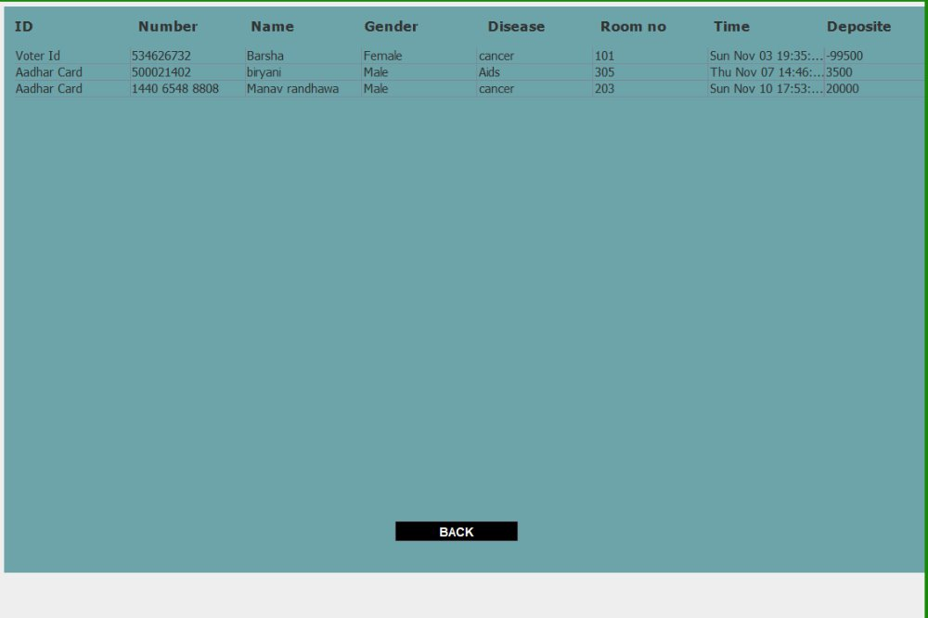
Fig 4.5:
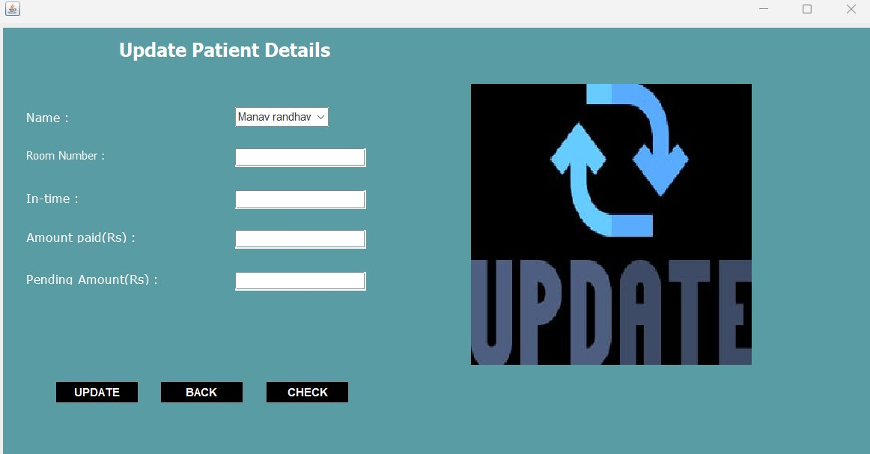
Fig 4.6:
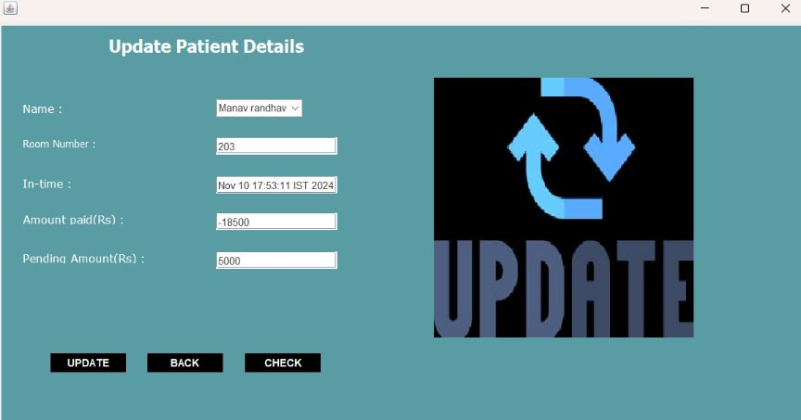
Fig 4.7:
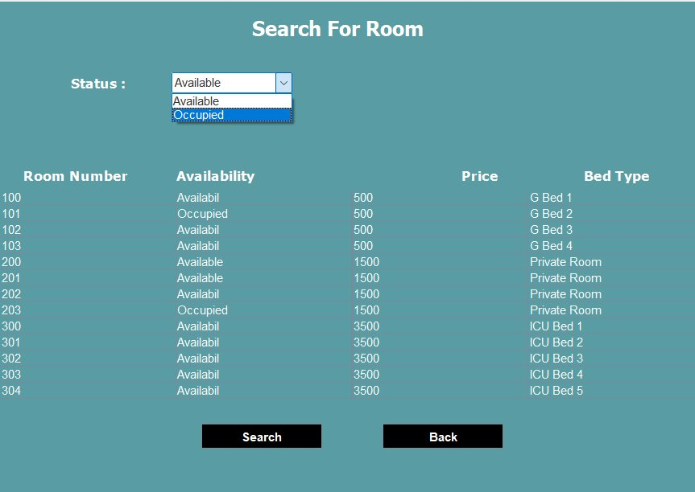
Fig 4.8:
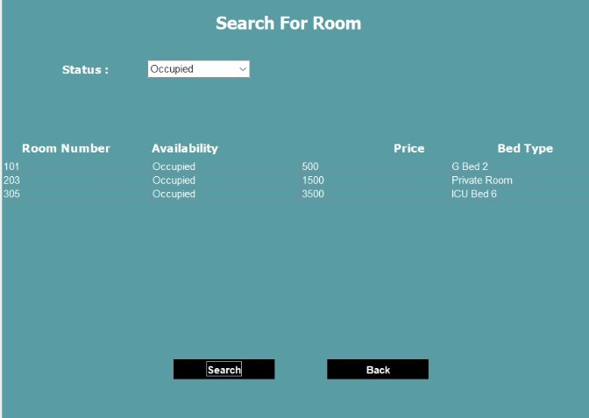
Fig 4.9:
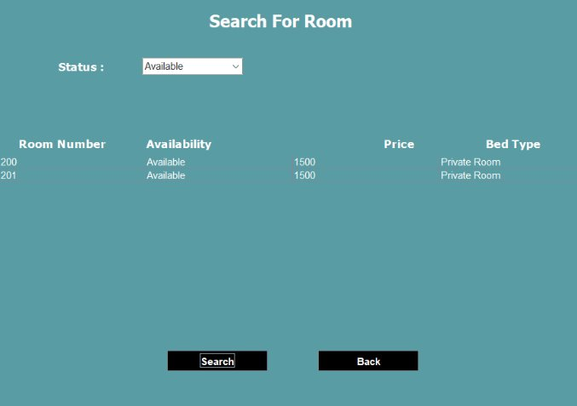
Fig 4.10:
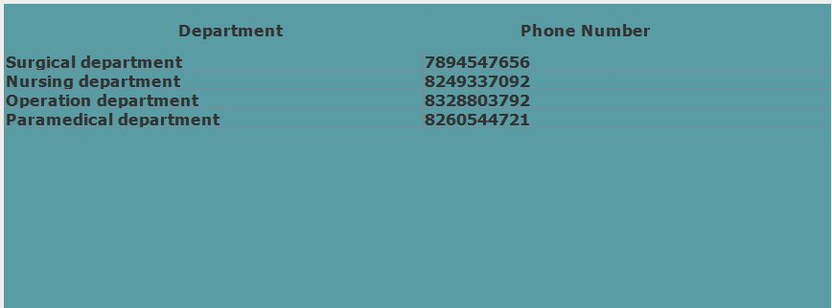
Fig 4.11:
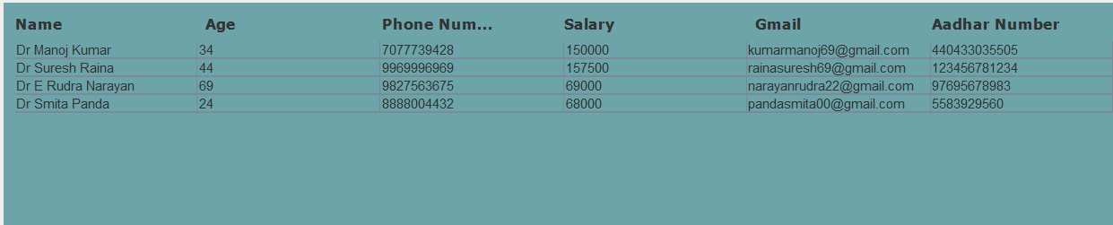
Fig 4.12:
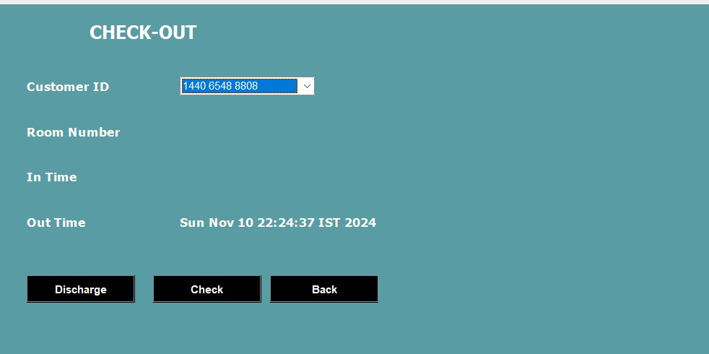Fig 4.13:
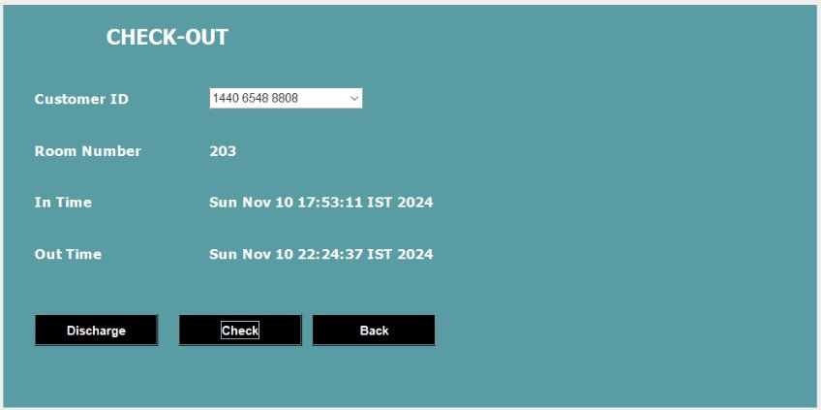
Fig 4.14:

CONCLUSION
The E-Healthcare Management System (EHMS) created using Java and MySQL improves how hospitals manage their daily operations. By automating important tasks like patient registration, scheduling appointments, keeping medical records, and billing, it reduces the workload on hospital staff and helps them focus more on patient care. The system ensures that all patient information is stored securely and can be accessed easily when needed.

This project not only solves current problems in healthcare management but also prepares for future advancements, such as integrating telemedicine and mobile applications. Overall, EHMS makes healthcare services more efficient, accurate, and patient-centered, demonstrating the practical use of programming and database skills to improve the healthcare sector.

FUTURE SCOPE

Telemedicine Integration:
- Enable remote consultations and follow-ups.
- Provide virtual care options for patients.
Mobile App Development:
- Offer mobile access for patients and staff.
- Facilitate appointment scheduling and medical record access via mobile devices.
Advanced Data Analytics:
- Implement predictive analytics for patient outcomes.
- Use data mining for better resource management and decision-making.
IoT Integration:
- Monitor patients remotely using IoT devices.
- Improve hospital asset management through IoT sensors.
AI and Machine Learning:
- Automate diagnostic processes.
- Enhance personalized patient care with AI-driven insights.

REFERENCE:
- Download IntelliJ IDEA – The Leading Java and Kotlin IDE
- MySQL :: MySQL Downloads
- Programming with Java - E Balagurusamy - Google Books

